a)

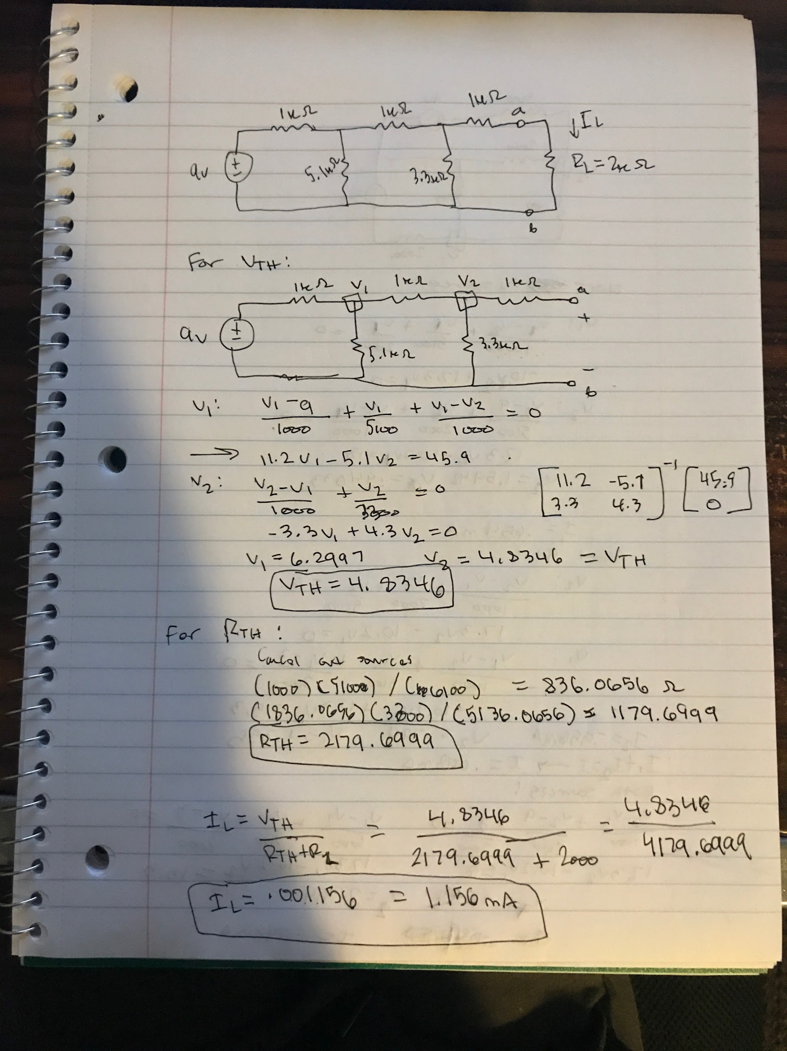

b)

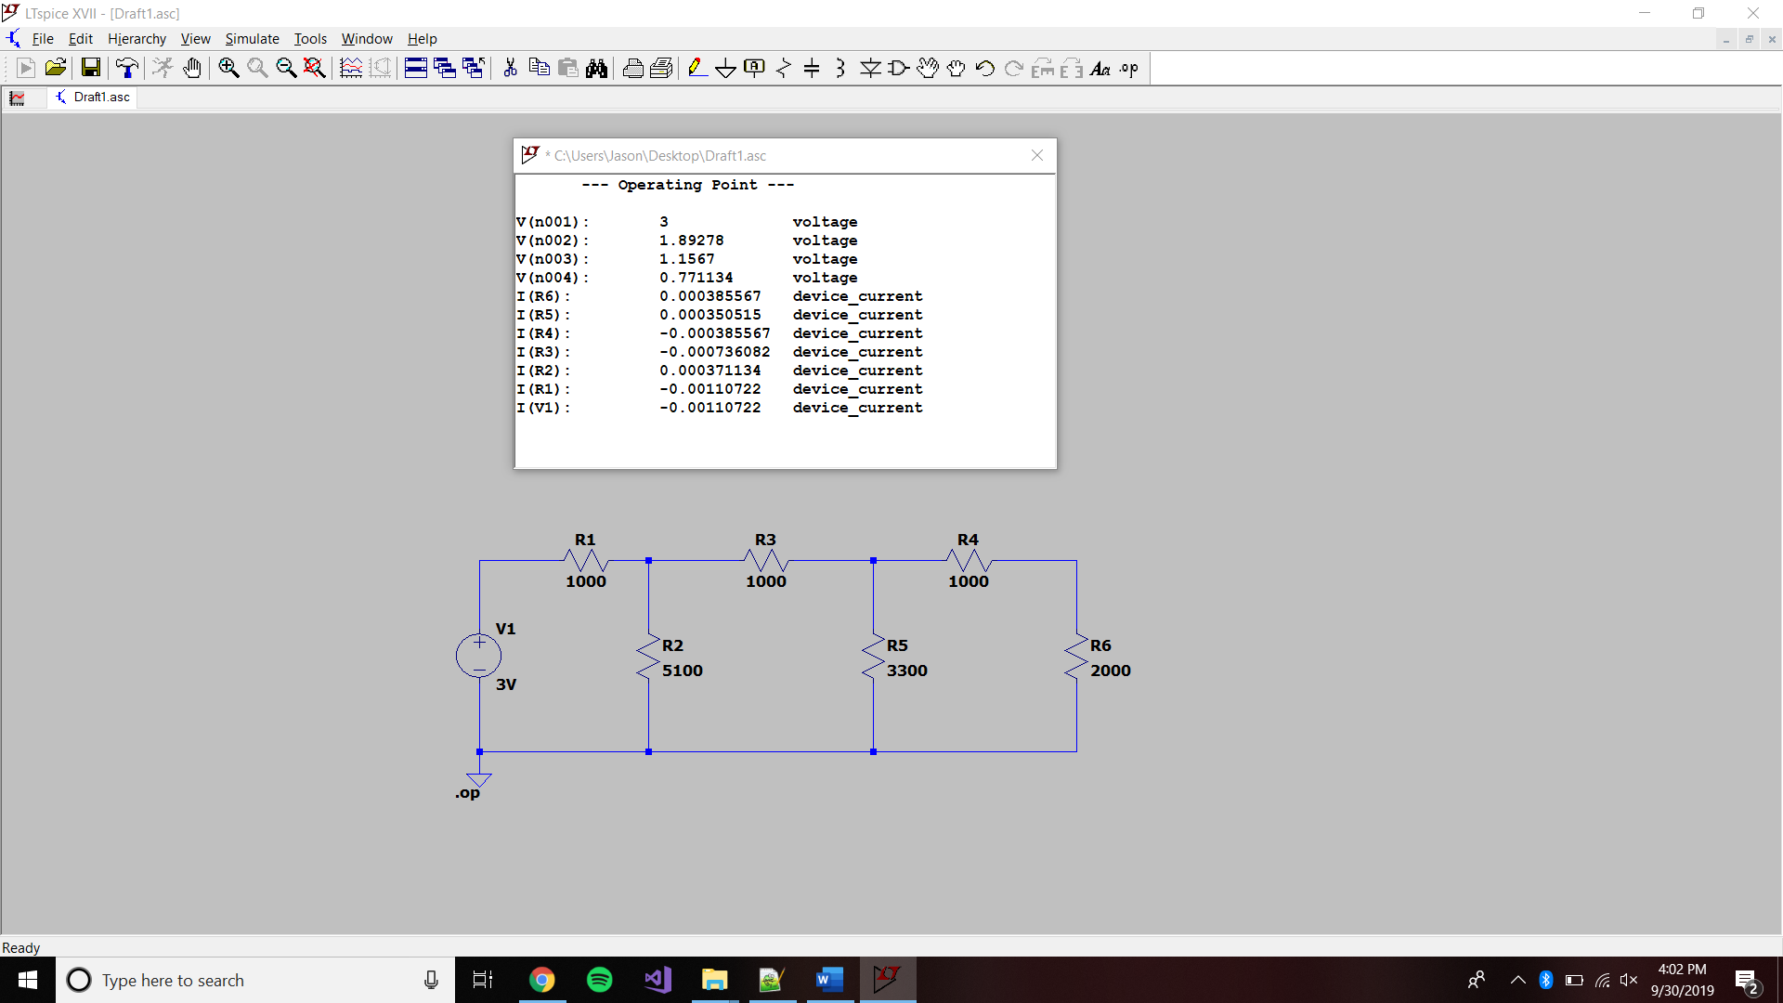

c)

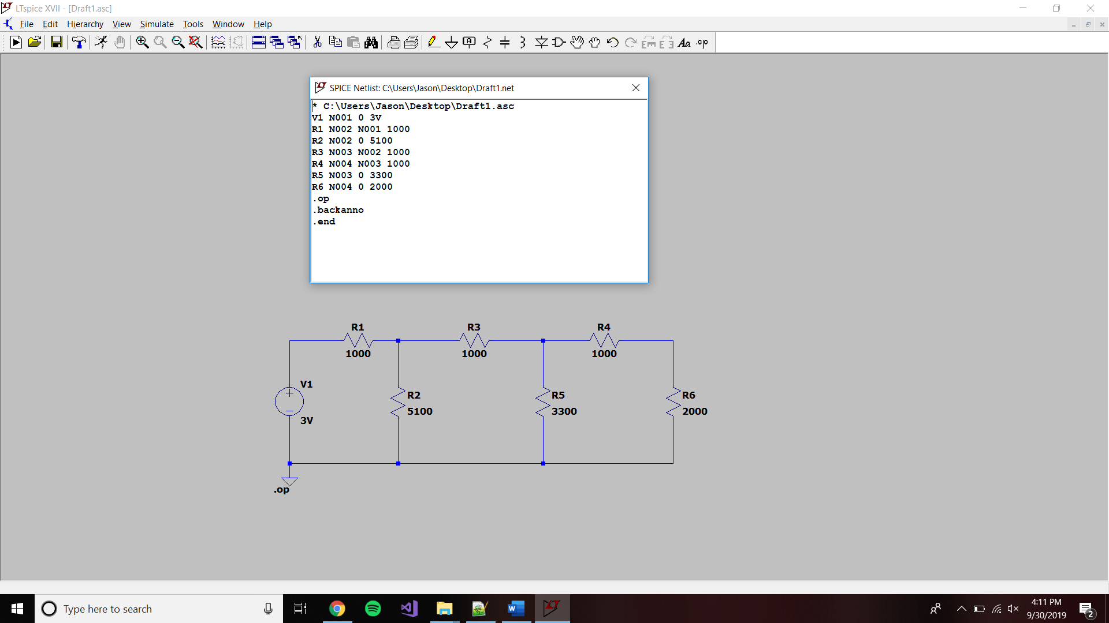

My netlist:

V1 N1 Ground

R1 N1 N2

R2 N2 Ground

R3 N2 N3

R4 N3 N4

R5 N3 Ground

R6 N4 Ground

To design my netlist, I just looked at the components and wrote down the nodes that the component connected to. My netlist is the same as the one Splice produced, although I wrote ground, not knowing that 0 is the symbol for connected to ground. Regardless of this, they describe the same circuit.

d)

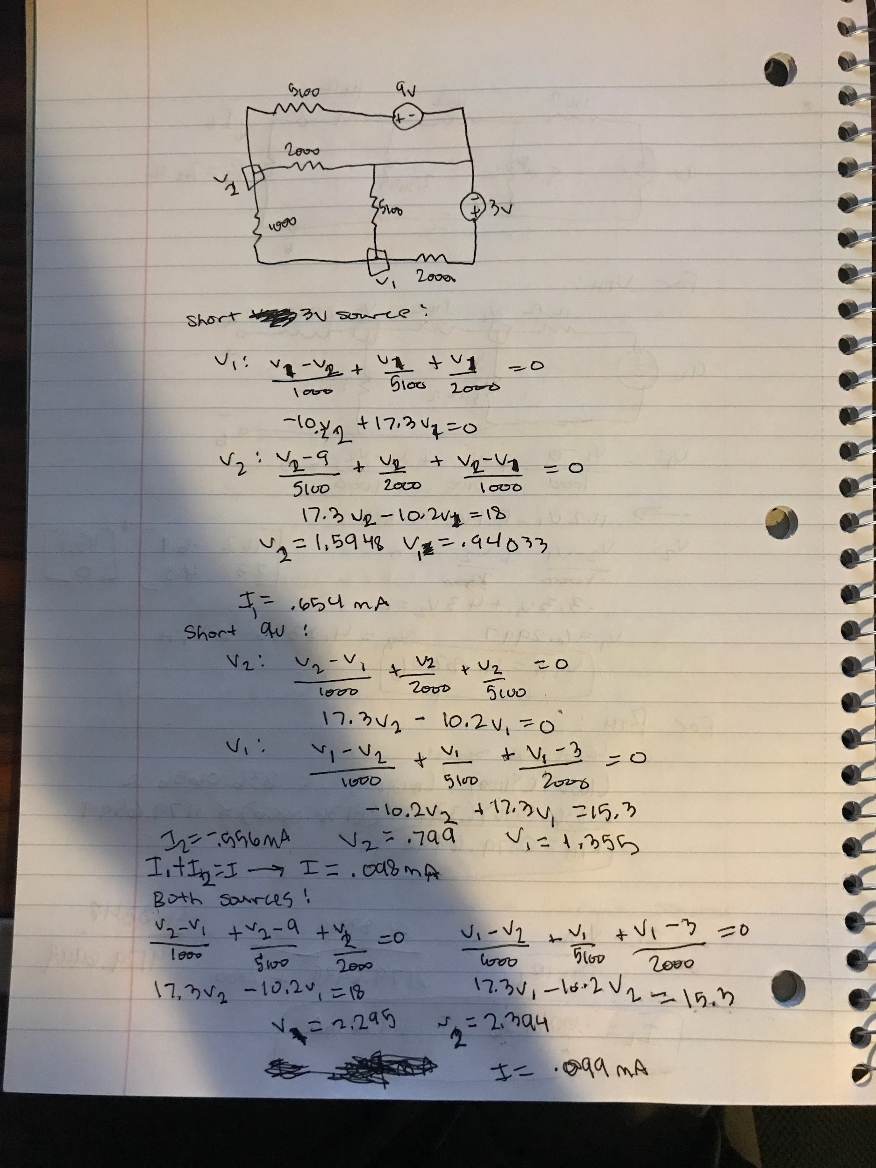

e)

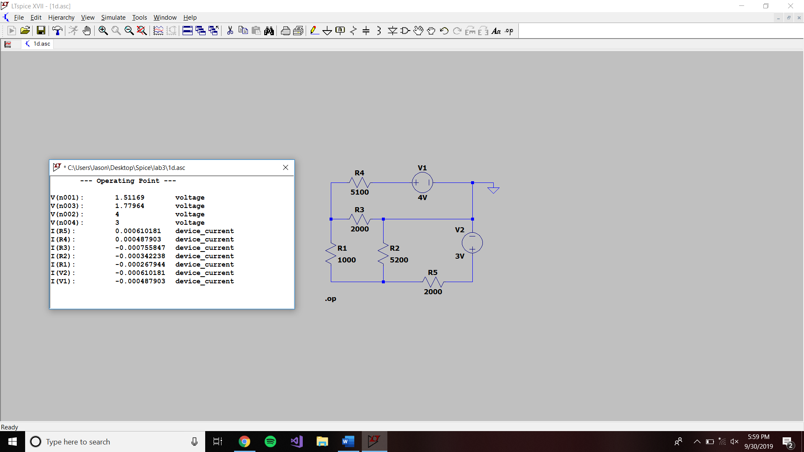

f)

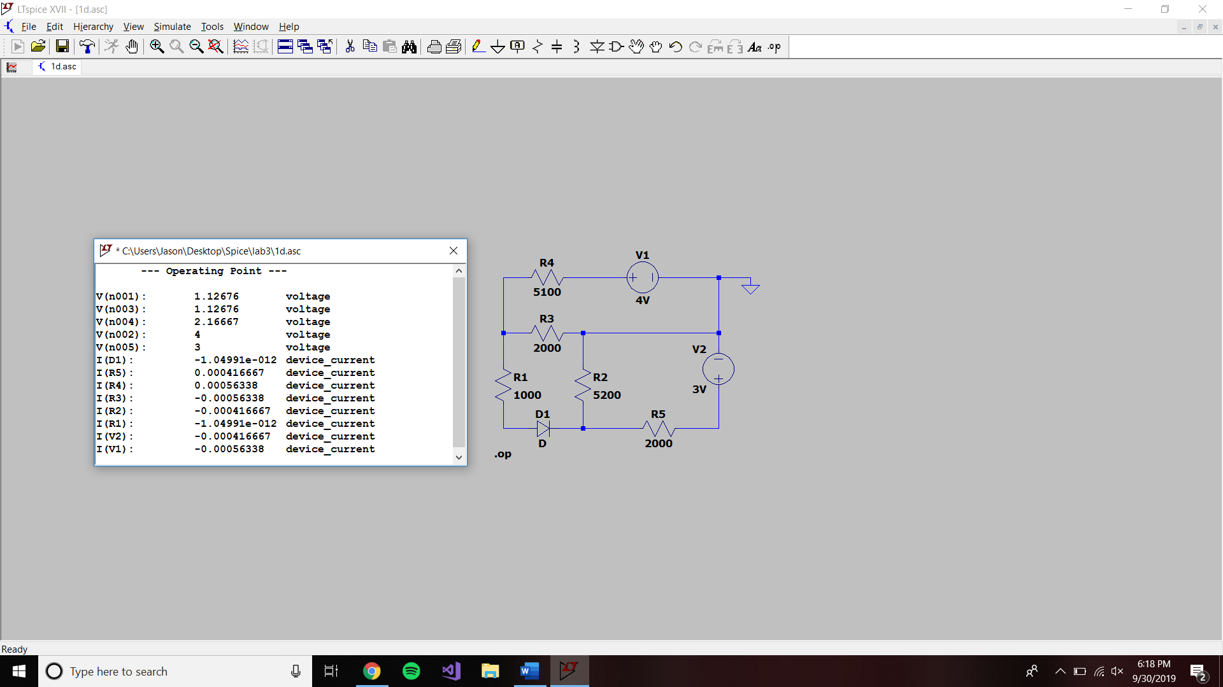

|  |  |  |  |
| --- | --- | --- | --- |
| VL (voltage over the 1kΩ resistor) | Calculation Part D  (No diode) | PSPICE Part E  (No diode) | PSPICE Part F  (with diode) |
| 1. V1 & V2 Present | .099 V | -.267 V | -1.04991E-12 V |
| 2. V1 only | .654 V | .290 V | .135 V |
| 3. V2 only | -.556 V | -.558 V | -2.177E-12 V |
| 4. Add line 2 & 3 | .098 V | -.268 V | 1.349E-4 V |
| 5. % difference  between line 1 and line 4 | .0101 | .00374 | 200 |

The columns for part D and E hold true for superposition, although the column that involved a diode did not follow the rules of superposition.